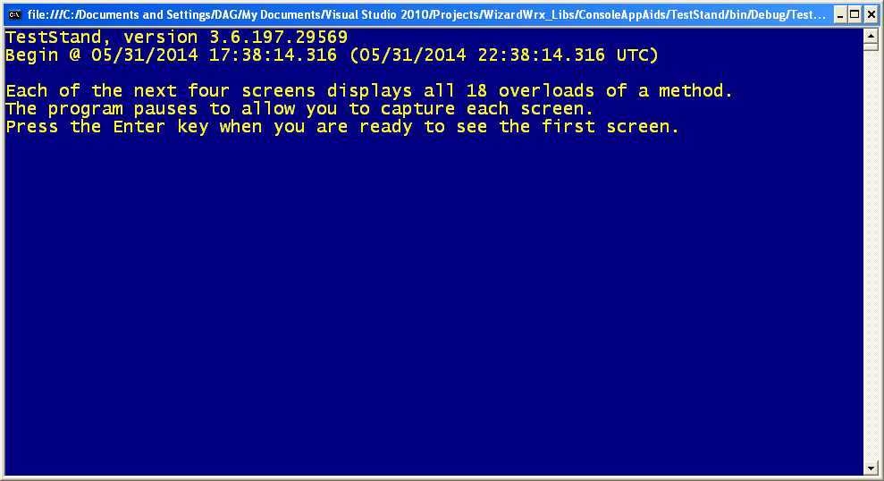
Figure 1 is the initial screen displayed by version 3.6.197.29569 of the test program for class library WizardWrx.ConsoleAppAids.
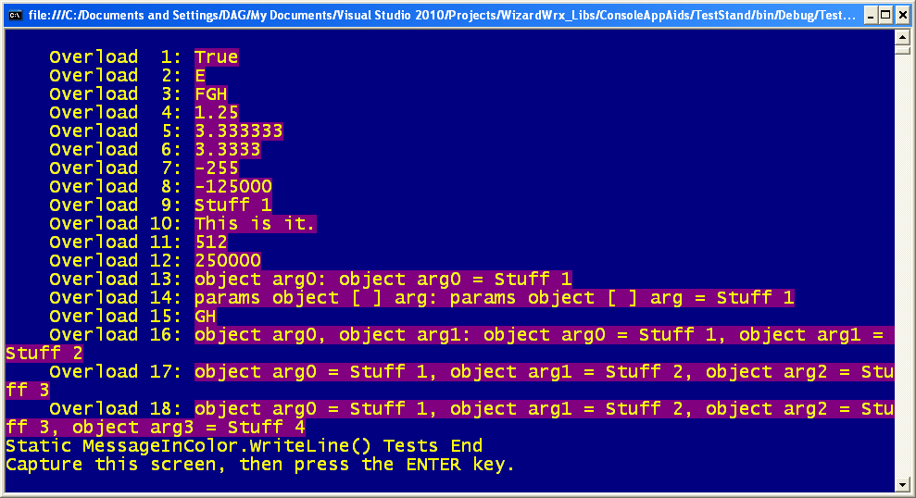
Figure 2 is the static MessageInColor.WriteLine test set, which demonstrates all 18 of its overloads.
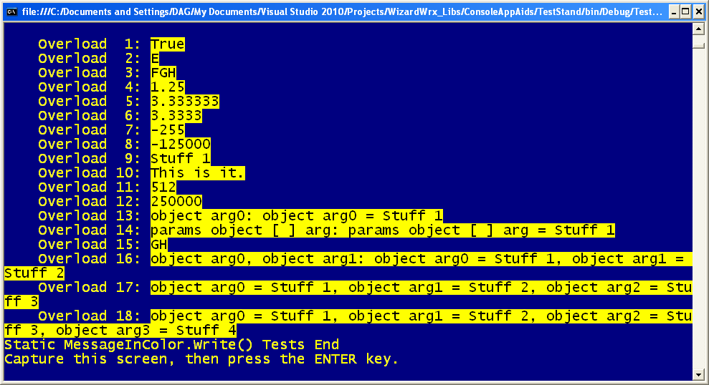
Figure 3 is the static MessageInColor.Write test set, which demonstrates all 18 of its overloads.
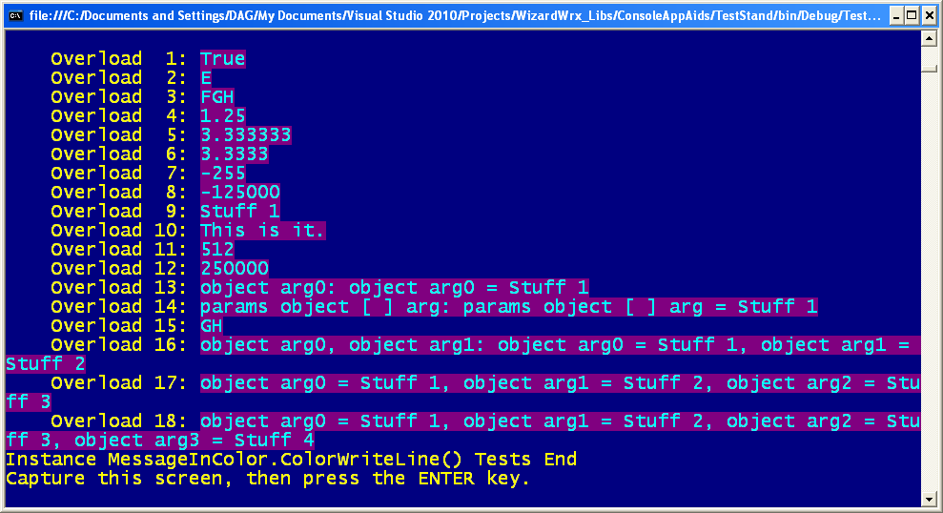
Figure 4 demonstrates all 18 overloads of the MessageInColor.ColorWriteLine method of an instance of the MessageInColor class.
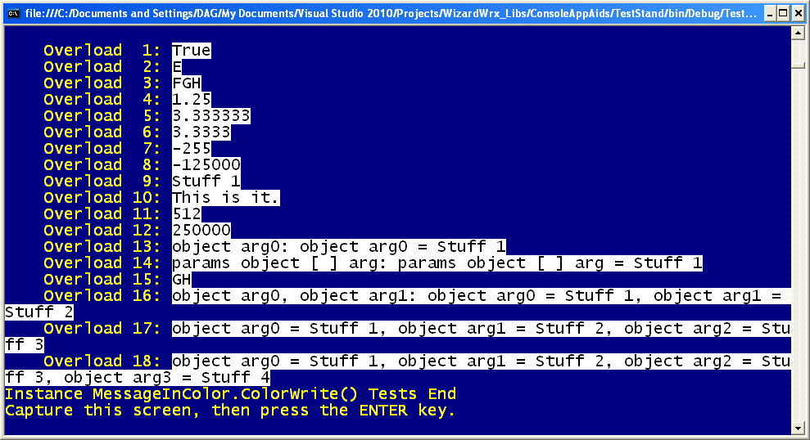
Figure 5 demonstrates all 18 overloads of the MessageInColor.ColorWrite method of an instance of the MessageInColor class.
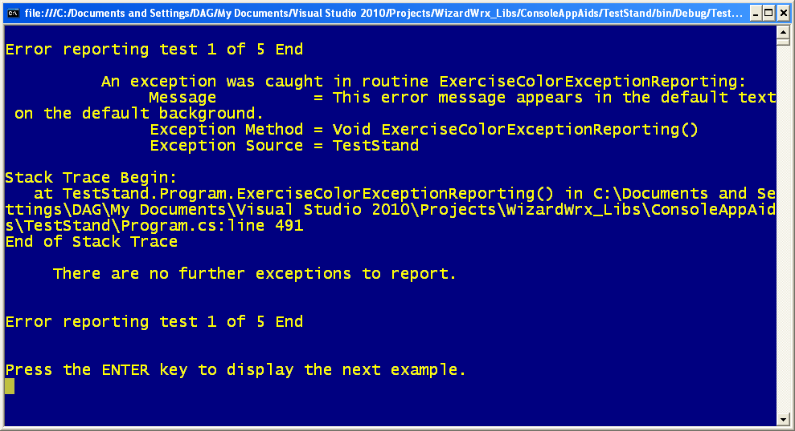
Figure 6 is the first of five examples of the deprecated static WizardWrx.ConsoleAppAids.ExceptionReporting.ReportException method, which shall remain, at least for a short while, for the benefit of NBReplT.exe, the only production program that has calls to written into it.
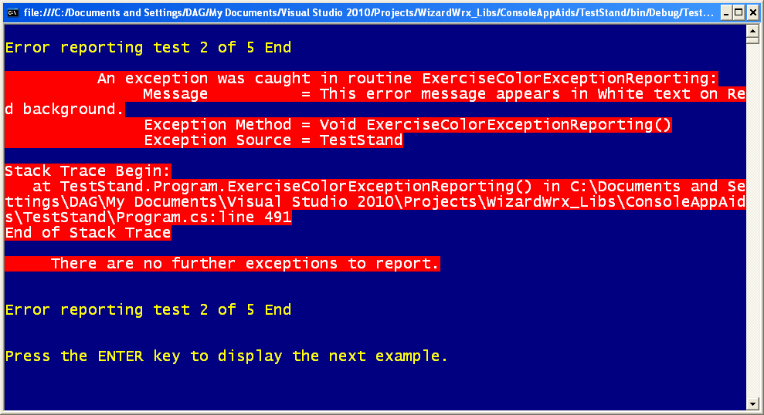
Figure 7 is the second of five examples of the deprecated static method WizardWrx.ConsoleAppAids.ExceptionReporting.ReportException, using white text on a red background, which is way over the top.
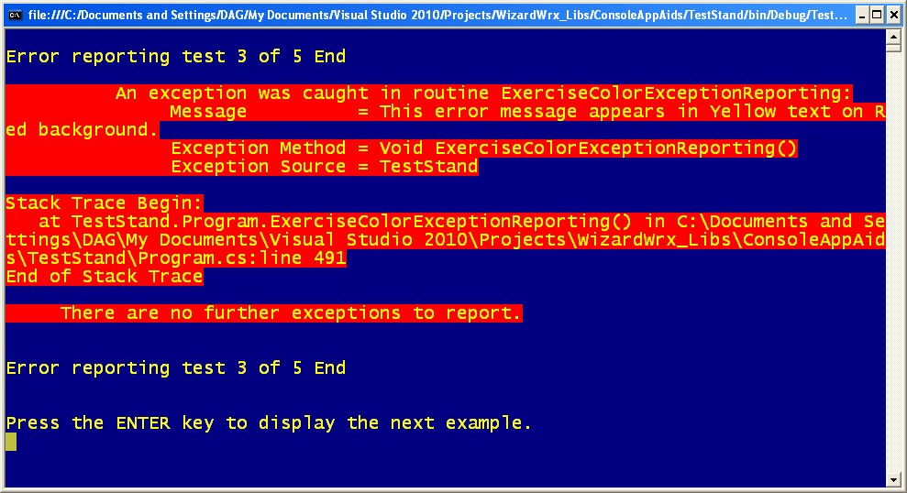
Figure 8 is the third of the five examples of the deprecated static method WizardWrx.ConsoleAppAids.ExceptionReporting.ReportException, rendered in yellow on red, which is only a tad better than the white on red shown in Figure 7.
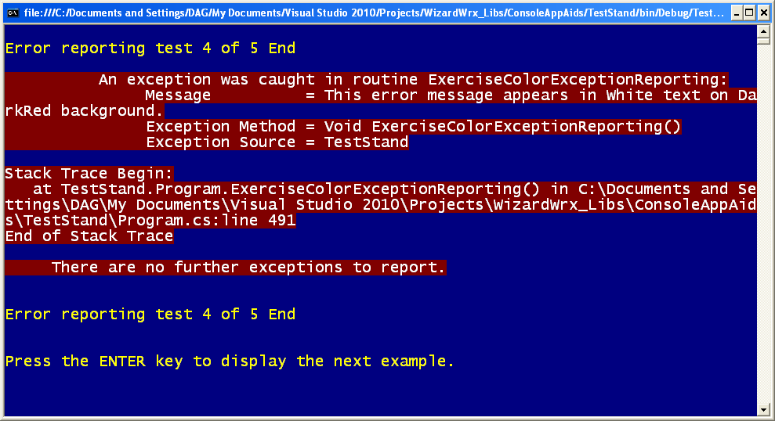
Figure 9 is the fourth of the five examples of the deprecated static method WizardWrx.ConsoleAppAids.ExceptionReporting.ReportException, rendered in the foreground color shown in Figure 7 on a much more appropriate dark red background.
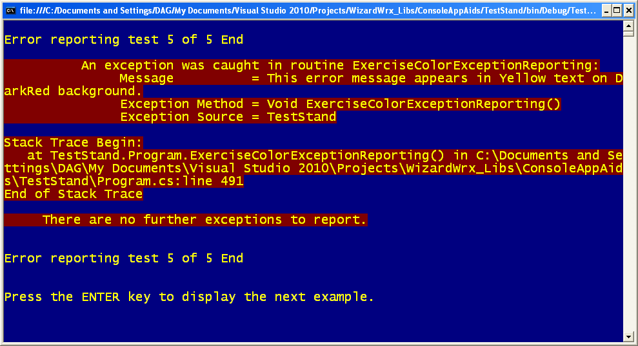
Figure 10 is the fifth of the five examples of the deprecated static method WizardWrx.ConsoleAppAids.ExceptionReporting.ReportException, rendered in the foreground color shown in Figure 8 on a much more appropriate dark red background.
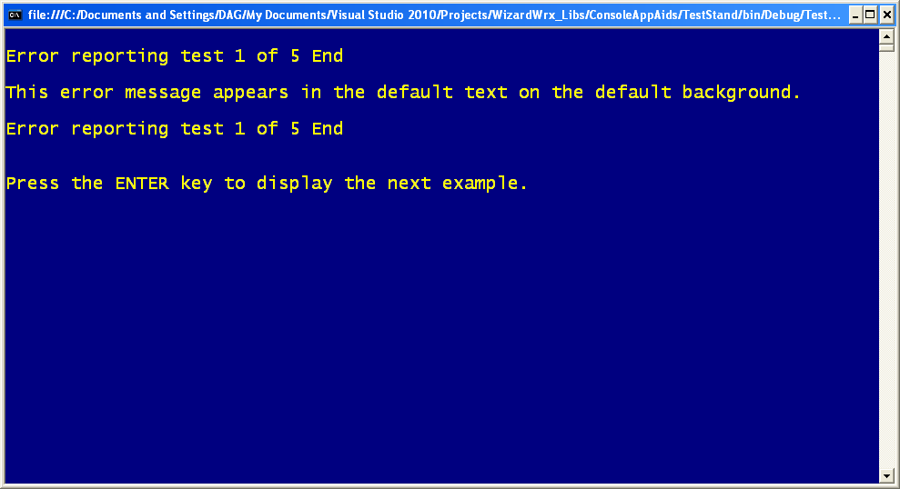
Figure 11 is the first of five tests, using the same foreground and background colors used in the last five screens to display a one-line message.
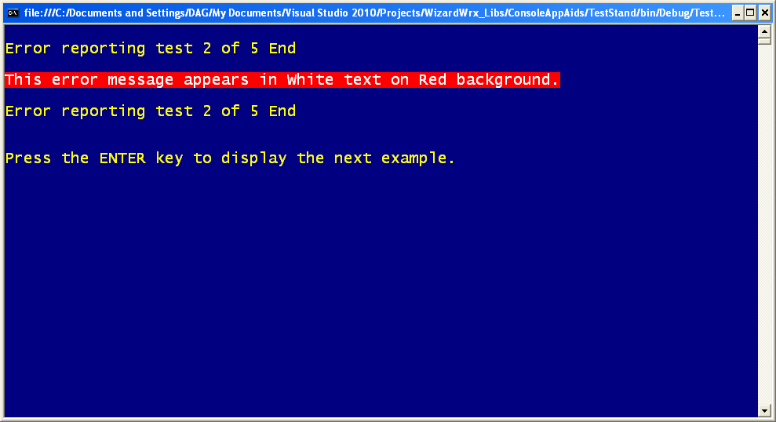
Figure 12 is the second of the five one-line message tests. Although the color combination is as harsh as ever, it is more tolerable for one line than for a whole screen full of text, as in Figure 7.
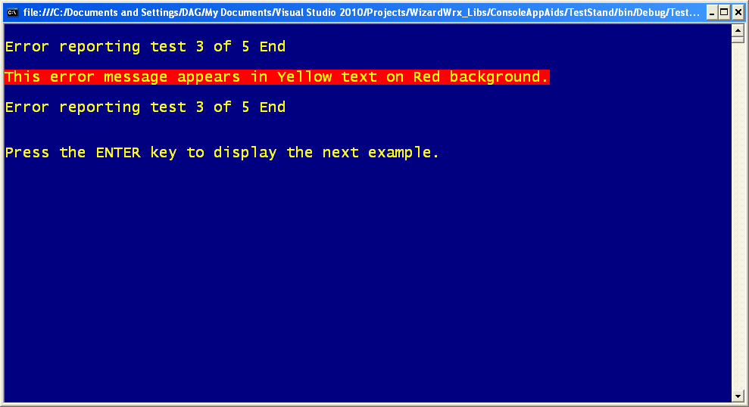
Figure 13 is the third of the five one-line message tests. The observations noted in the caption of Figure 12 apply equally to this example.
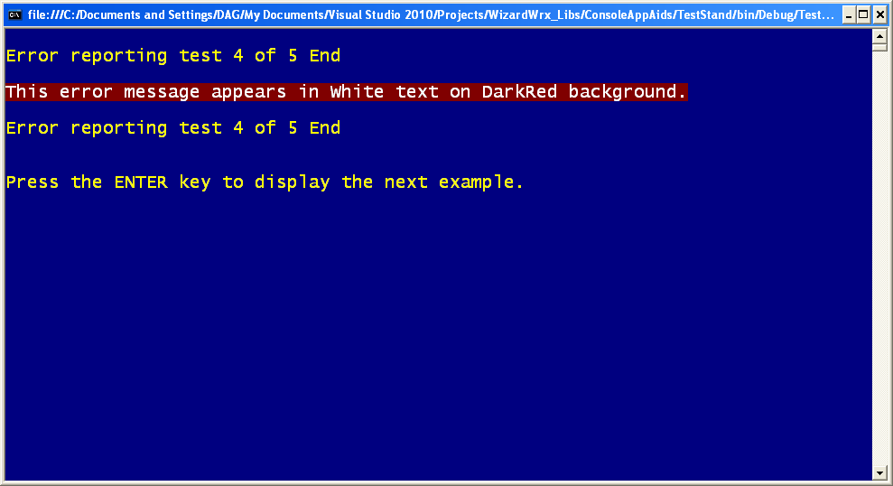
Figure 14 is white text on the more subdued dark red background, applied to a limited amount of text. About four months of regular use in a production utility that frequently generates brief error messages in normal use confirm the effectiveness of this color combination.
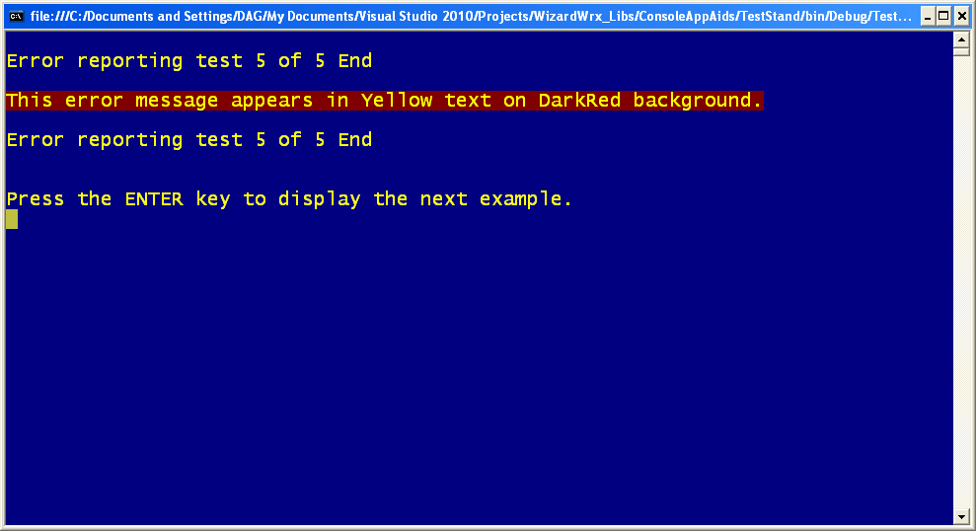
Figure 15 is yellow text on the more subdued background that the Console class, and MS-DOS, long before it, calls Dark Red. The yellow text is a little more jarring, and it might be appropriate for a really serious error. However, since my wife thinks this combination blurs the text, I have been reluctant to use it in production code.
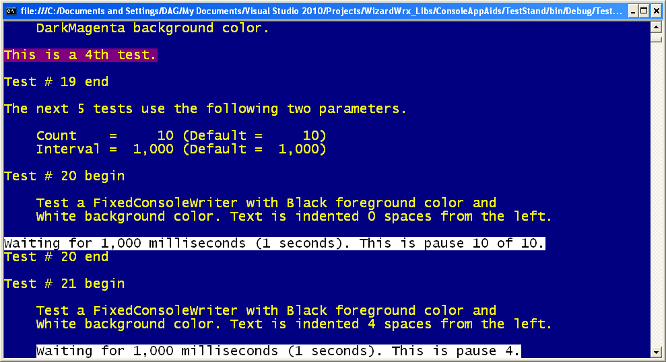
Figure 16 displays the first two examples of the FixedConsoleWriter class, which displays text at a fixed position relative to the left margin. The first test demonstrates that flush left is a legal starting position. The Fixed attribute actually refers to the vertical position on the screen.
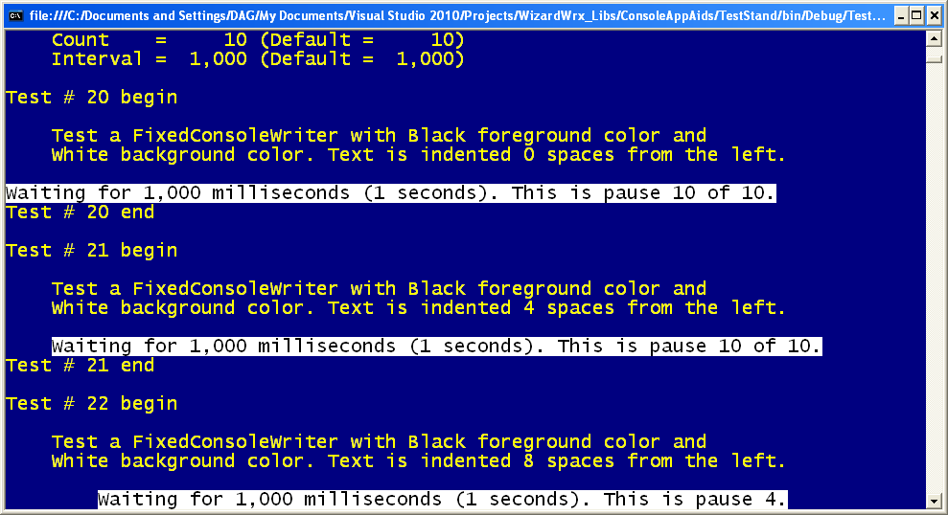
Figure 17 displays the first three tests of the FixedConsoleWriter class, moving the starting position progressively further from the left edge, with the goal of forcing a line wrap.
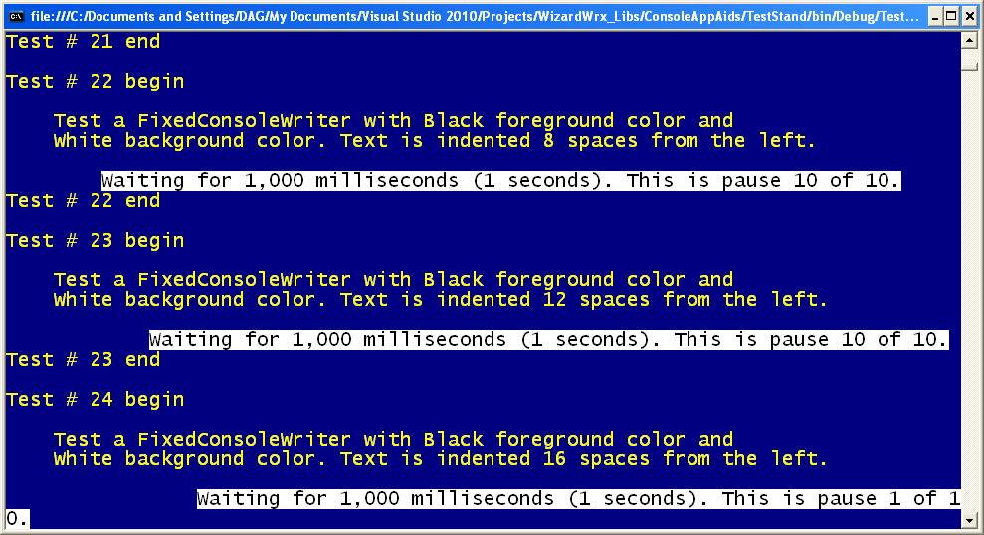
Figure 18 is the first of three illustrations of how the FixedConsoleWriter class behaves when the text wraps around.
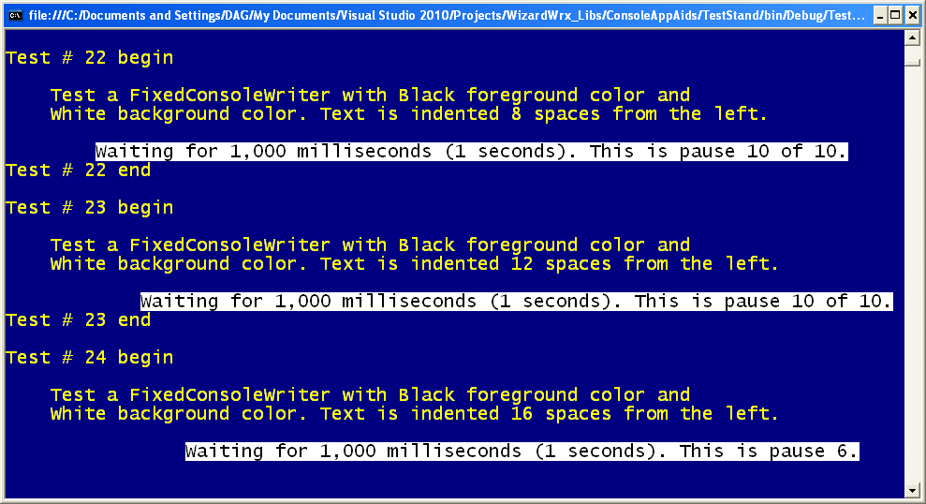
Figure 19 is the second of three illustrations of how the FixedConsoleWriter class behaves when the text wraps around. The vertical position is unchanged from that of the wrapped message shown in Figure 18, because the carat retreated when it wrote the shorter line.
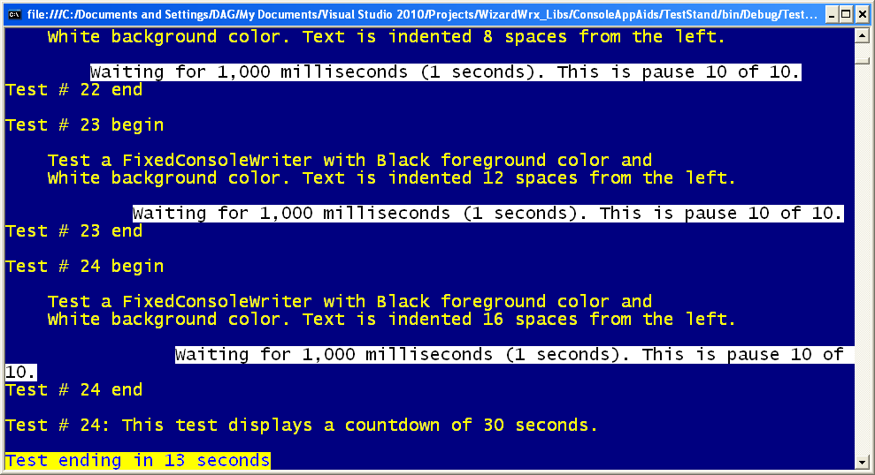
Figure 20 is the second of three illustrations of how the FixedConsoleWriter class behaves when the text wraps around. The carat is positioned so that the next line is written below the last line occupied by part of the last fixed message, and the screen resumes scrolling.
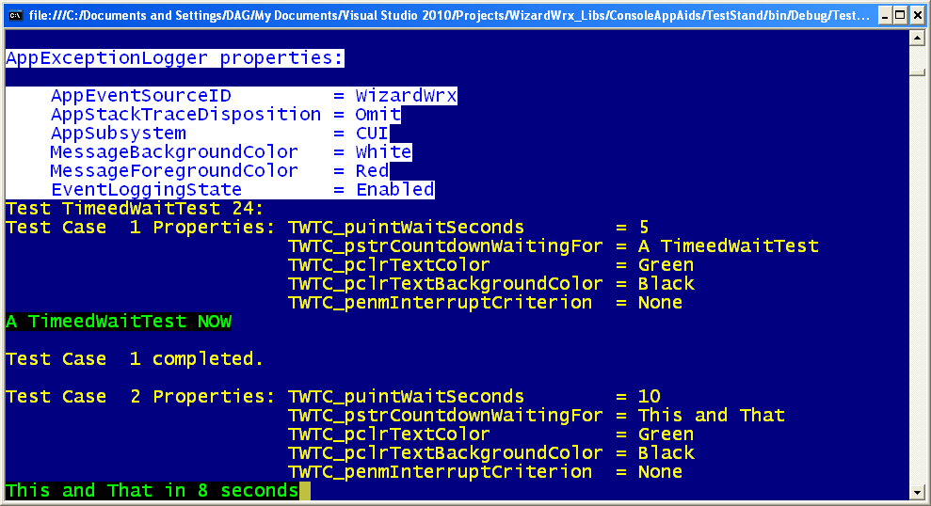
Figure 21 is the first of a series of demonstrations of a TimedWait method that combines the FixedConsoleWriter class with a countdown clock built around the Thread.Sleep method to freeze the screen for a maximum number of seconds.
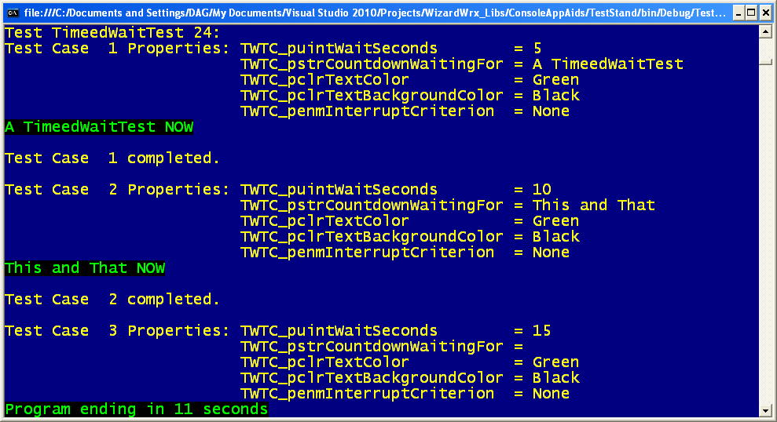
Figure 22 displays more permutations of the argument values that can be passed into the TimedWait method.
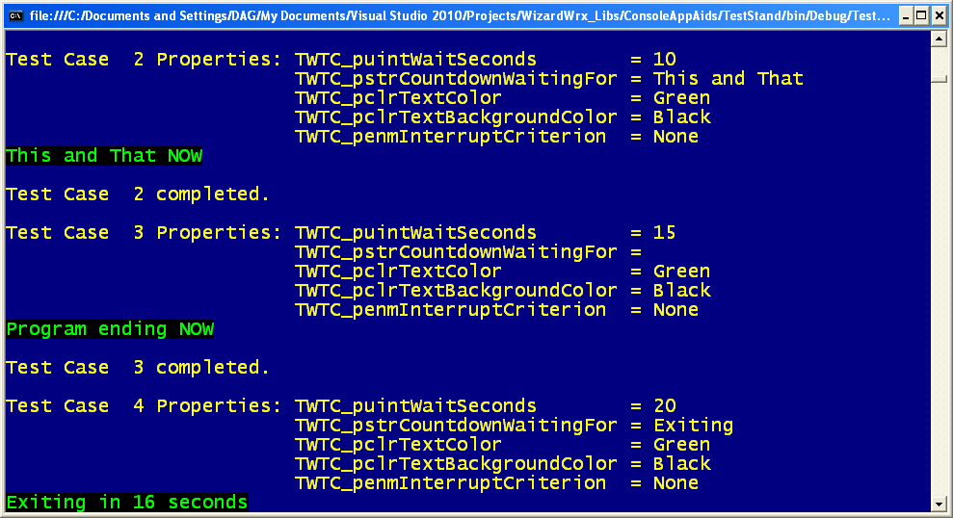
Figure 23 displays even more permutations of TimedWait, the most interesting being the one where argument TWTC_pstrCountdownWaitingFor is left blank, causing the display to say “Program ending.”
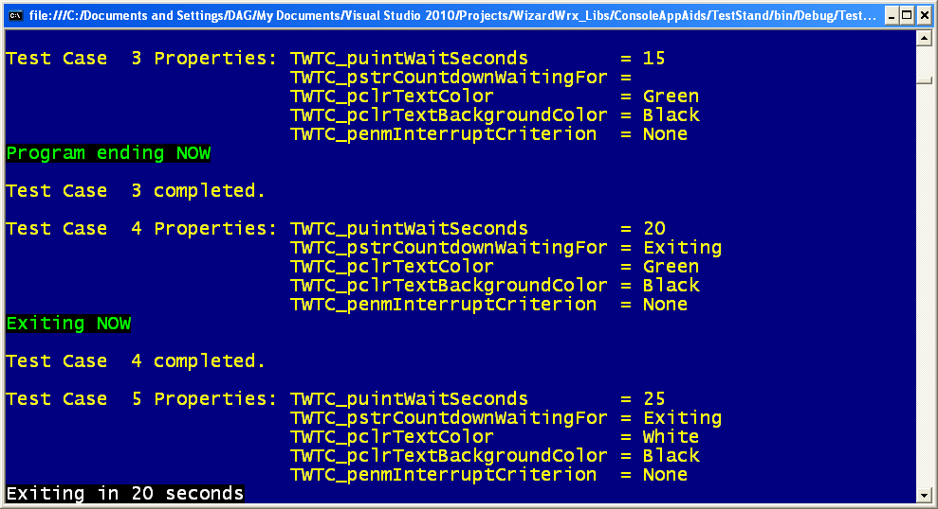
Figure 24 demonstrates control over foreground (text) and background colors used by TimedWait.
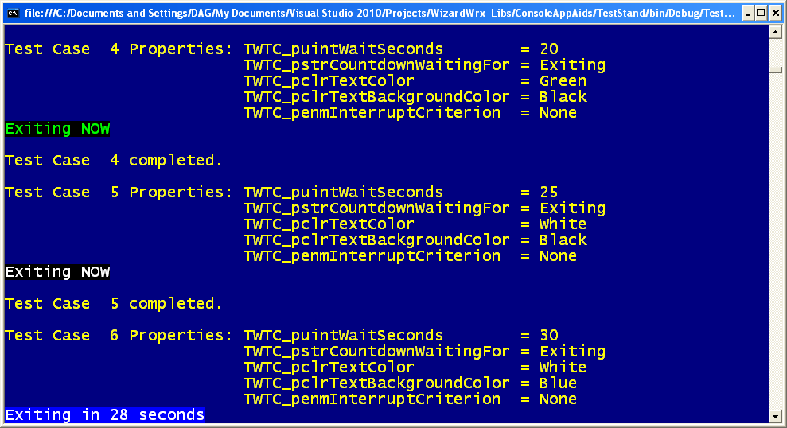
Figure 25 demonstrates yet another color combination that can be used with TimedWait; the last example changes the foreground and background colors.
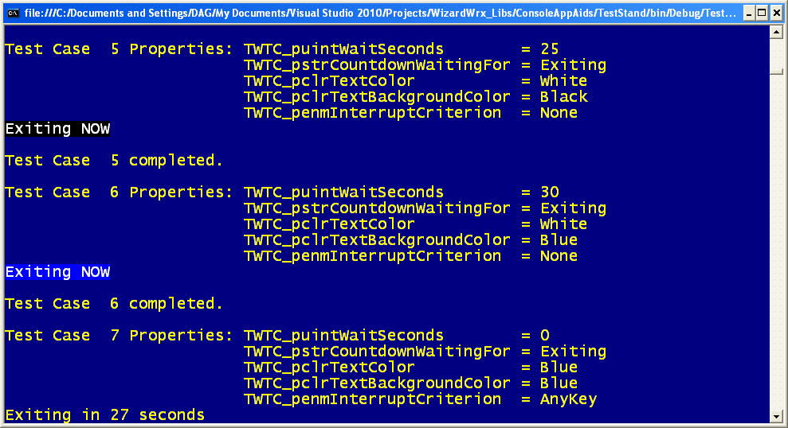
Figure 26 demonstrates that specifying the same colors for foreground and background causes TimedWait to use the default screen colors. Although this example shows Blue, any color has the same effect.
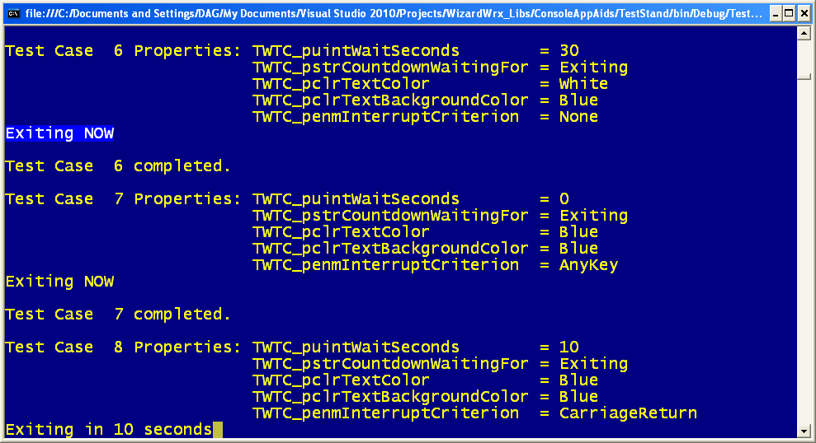
Figure 27 illustrates an early exit from TimedWait in case 7. Currently, there is no provision for indicating that the countdown was interrupted.
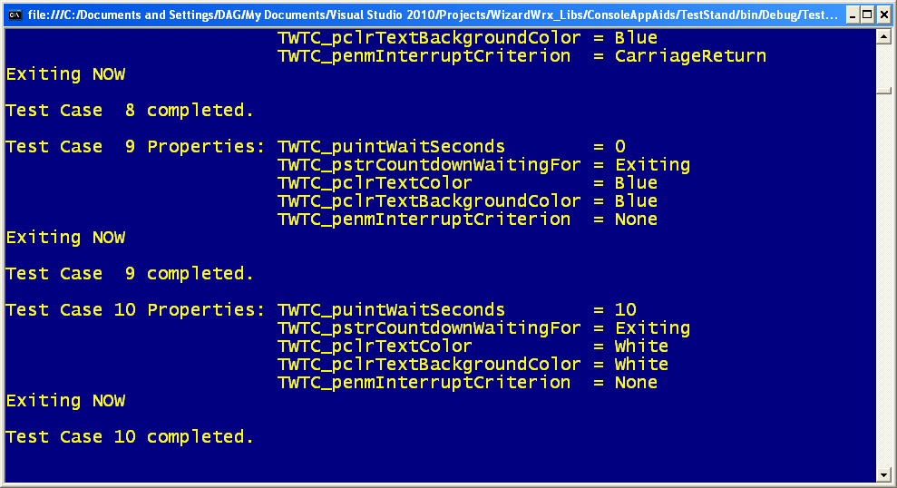
Figure 28 displays the remaining permutations of TimedWait parameters.
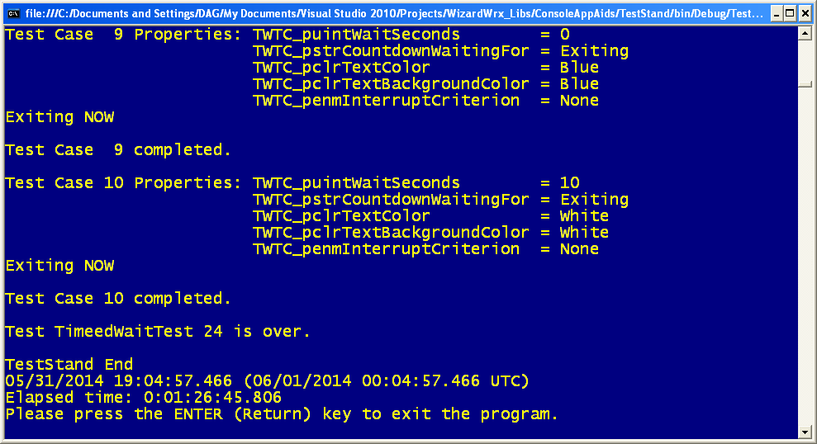
Figure 29 is the final screen displayed by the test program. Since it is running in debug mode, it waits for a carbon unit.

